Circle Language Spec: Inheritance

System Command Extension
Another way to specialize a derived object is to let it define extra functionality around a system command. The previous section was actually a demonstration of how to extend the implementation of the Execute system command. But other system commands can be extended as well, such as the Value Set command. Here is an example where the Value Set command is post-extended by implementing the Value Changed event.

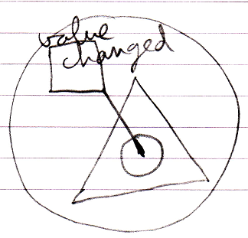

So then the derived class defines something that will be run every time the object’s value changes.

Author & Copyright: Jan-Joost van Zon Date: May 19, 2010 – July 17, 2010 Location: Oosterhout, The Netherlands Status: Finished

